


Empathy Map

Date | 1 October 2026
Team ID | SWTID-2026-2672
Project Name | EduGenie – Google Gemini Powered Learning Assistant
Maximum Marks | 4 Marks

Empathy Map

An Empathy Map is a simple tool used to understand a user's needs, expectations, problems, and emotions from the user's point of view. It helps the project team look beyond the technical solution and understand how the target user experiences the problem.

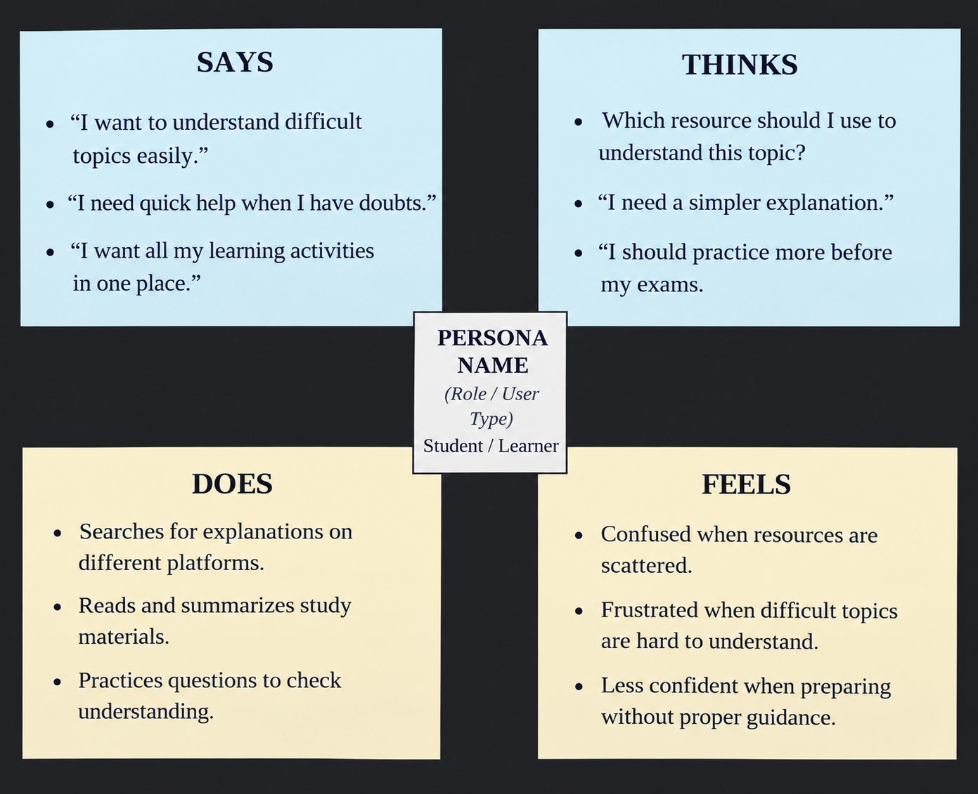s

